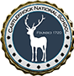
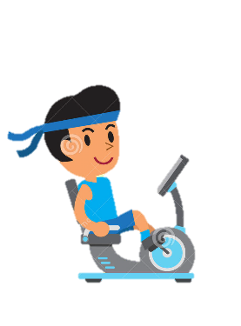
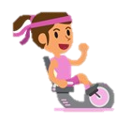
CNS PA Fundraiser 2021
“Cycling for CNS”
Sponsorship Prizes for the Winning Lines
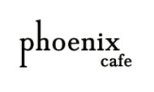
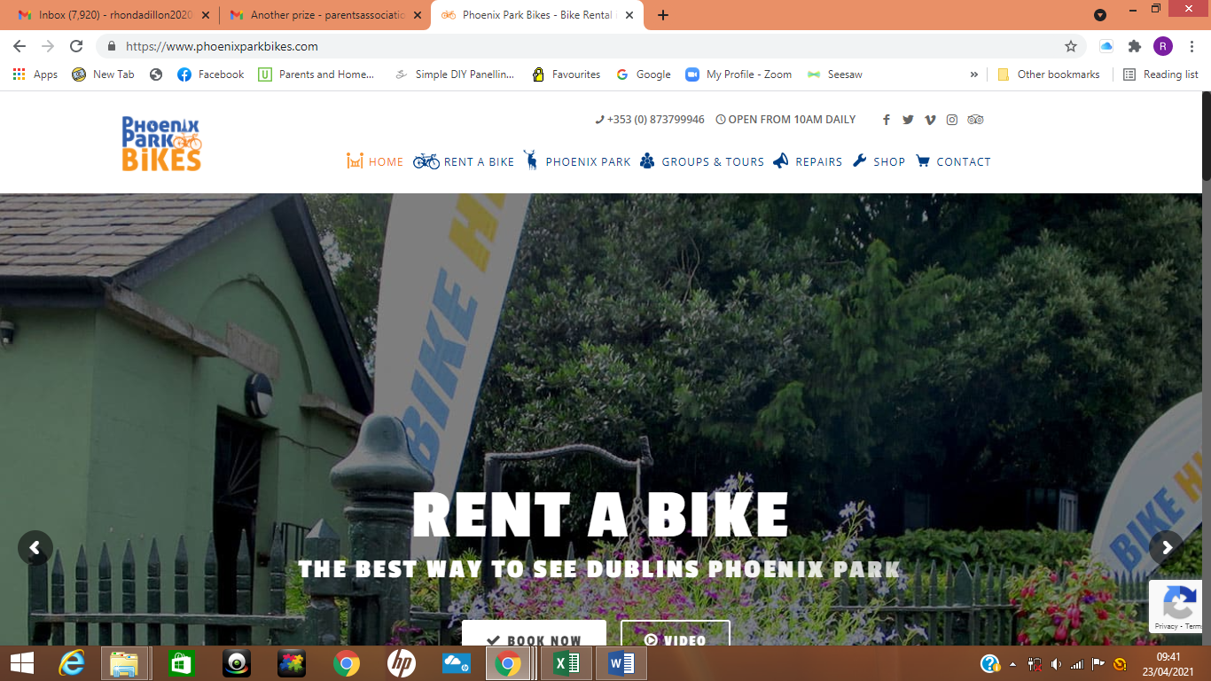
Picnic in the Park
1 Day Bike Hire for a Family of 5 from Phoenix
Park Bikes & €70 voucher to spend in the
Phoenix Café

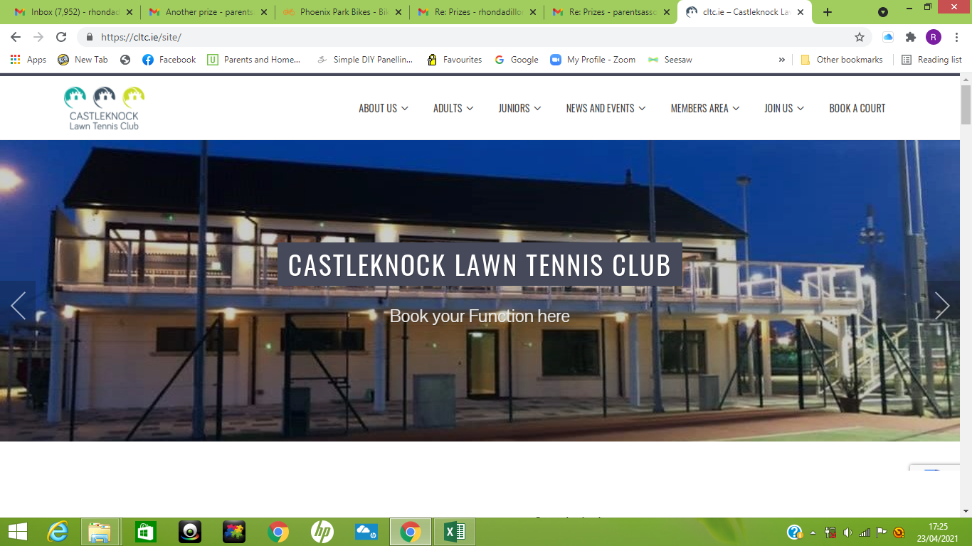
Junior Membership for 2021 Season
Castleknock Tennis Club

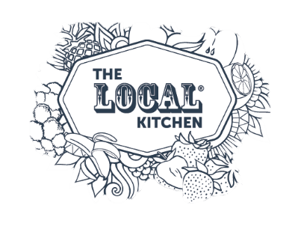

Cheese & Charcuterie Board for 2 incl. Wine
Beau-Vino / The LOCAL Kitchen

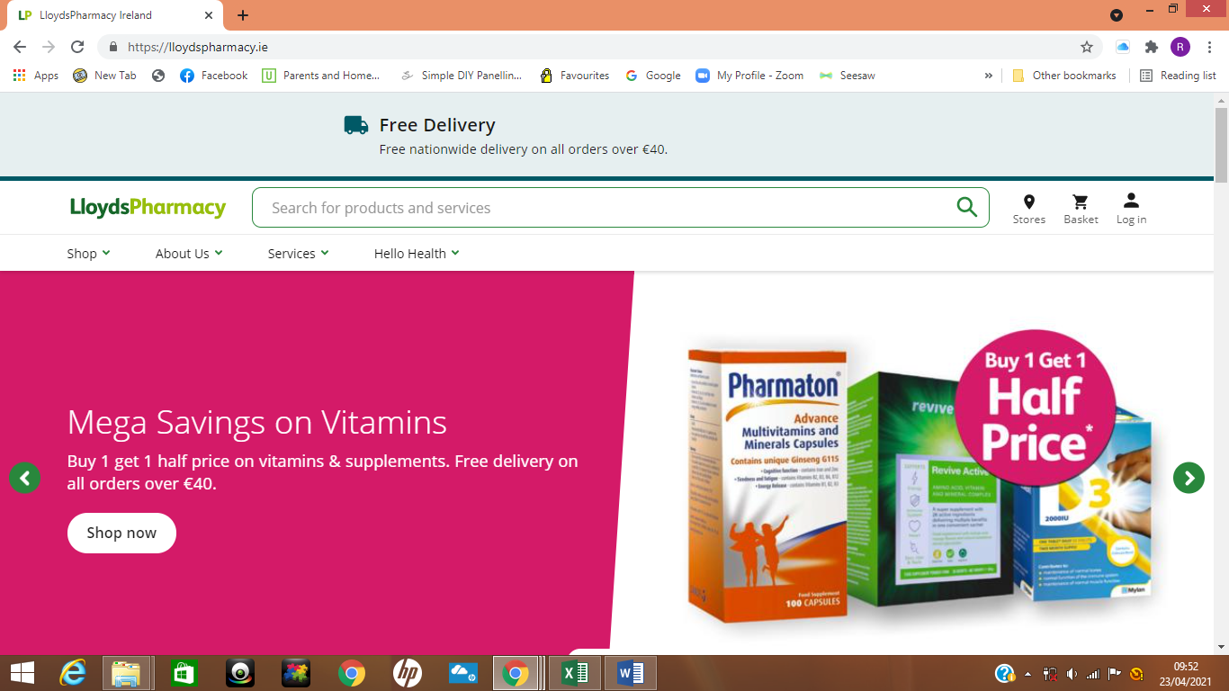
Pampering Hamper
Lloyds Pharmacy, Castleknock Village
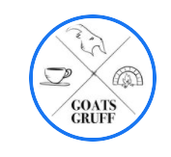
Family Pizza Night!
4 Wood Fired Neapolitan Pizza’s accompanied by 2 Sides & Desserts!!
Goats Gruff, Strawberry Beds

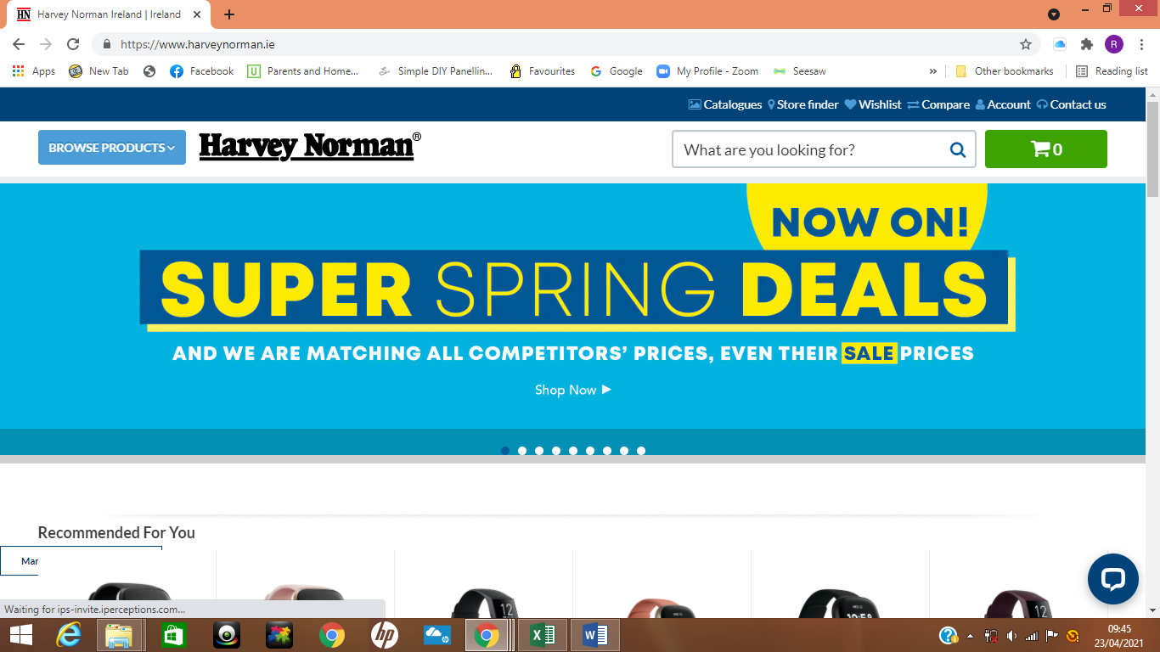
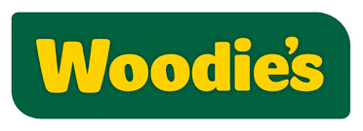
Invest in Rest!
Luxurious “Linen Room” King Size Duvet accompanied with
a scented surprise!
Harvey Norman & Woodies
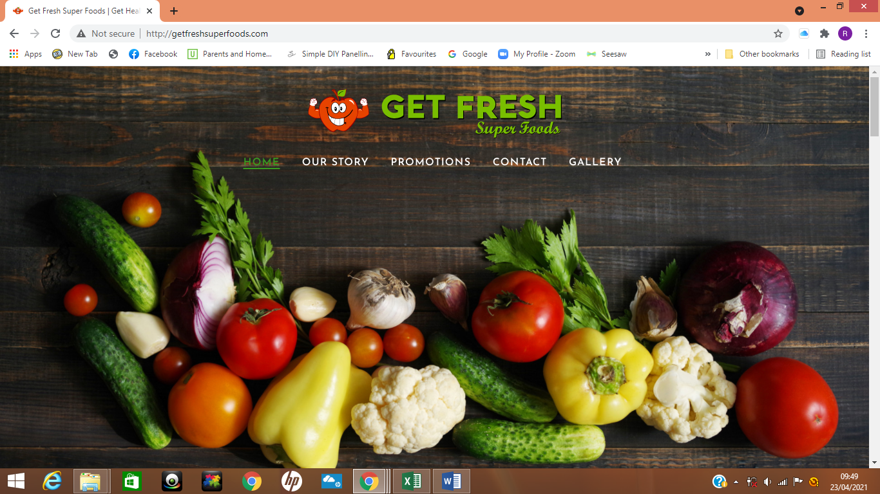
Get Healthier-Get Fitter-Get Fresher
A delicious and nutritious Superfood filled Hamper
Get Fresh Superfood, Castleknock

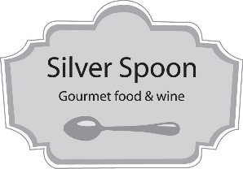
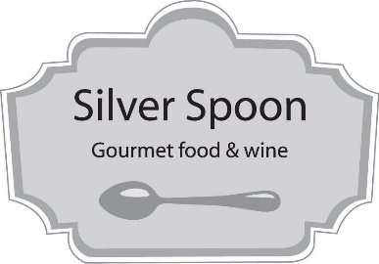

It’s All About The Coffee!
€25 voucher

PRIZES FOR THE SPONSORSHIP CARD SELLERS
♥ There are 3 Smyths Vouchers for the three sponsorship cards drawn♥

